DAY 3 -> 13-05-2026
Project 1: Customer Churn Prediction & Lifetime Value (LTV) Engine
EDA -> Dataset Profiling & Data Understanding
DONE BY -> ANANTHARAJAN V B

DATA SET PROFILING AND DATA UNDERSTANDING
Dataset Profiling
Dataset profiling is the process of checking and exploring the dataset before starting any analysis or machine learning work. In this step, the dataset is examined to understand how many rows and columns are present and what kind of information each column contains. We also check the data types, unique values, and overall structure of the data. For example, columns like customer age, monthly charges, or contract type help us understand customer behavior. This step helps in getting a clear idea about the dataset instead of directly jumping into model building. It also makes it easier to identify whether the dataset is organized properly for further processing.

Data Understanding
Data understanding focuses on learning how the data behaves and identifying possible issues inside the dataset. In this stage, missing values, duplicate records, and inconsistent entries are inspected carefully. For example, some customers may have blank values in important columns like total charges or payment method. By understanding these problems early, we can clean the dataset properly before training the model. This step also helps in understanding which features may strongly affect customer churn. Overall, data understanding helps in making better decisions during preprocessing, visualization, and machine learning stages.
DIFFERENT METHODS
df.head()
The df.head() function is used to display the first few rows of the dataset. It helps in quickly understanding how the data looks, including column names and sample values. This is usually the first step performed after loading a dataset into a dataframe.
OUTPUT
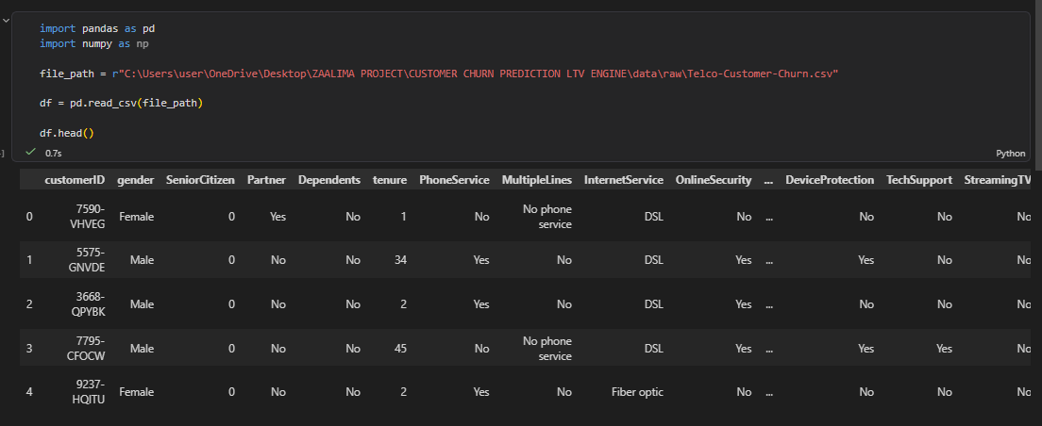

df.shape
The df.shape function is used to find the total number of rows and columns present in the dataset. It gives a quick overview of the dataset size and helps in understanding how large the data is before analysis begins.

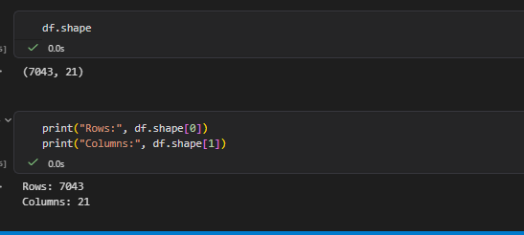
df.isnull().sum()
The df.isnull().sum() function calculates the total number of missing values in each column. This helps in understanding which columns require cleaning or preprocessing before model training and analysis.

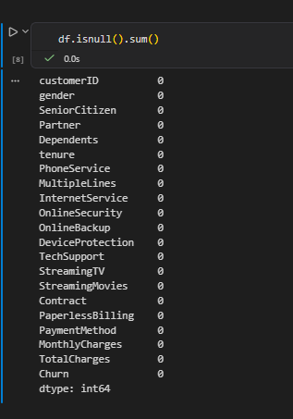

DAY 4, DAY 5 WILL BE CONTINTED SAME TASKS IN MORE DETIAILED MANNER

